Module 9.2 Assignment
Miguel Fernandez
3/01/26
1.
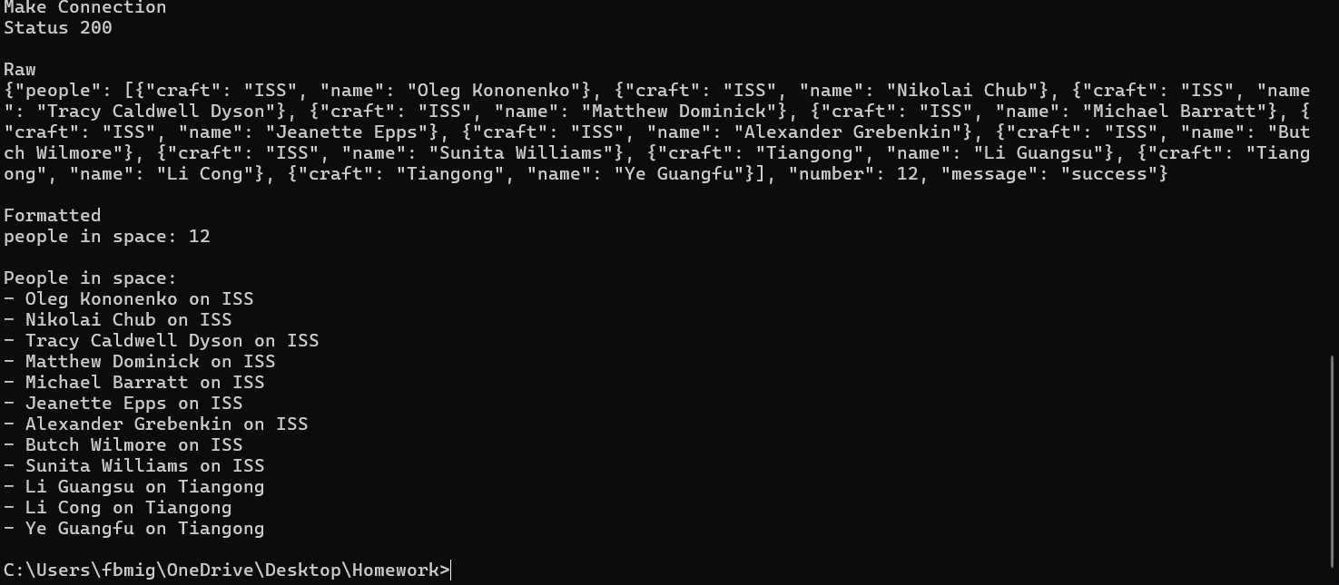
2.
